Assignment-4

Plasma Donor Application

Team ID : PNT2022TMID52198

1.Pull an image from docker hub and run it in docker playground

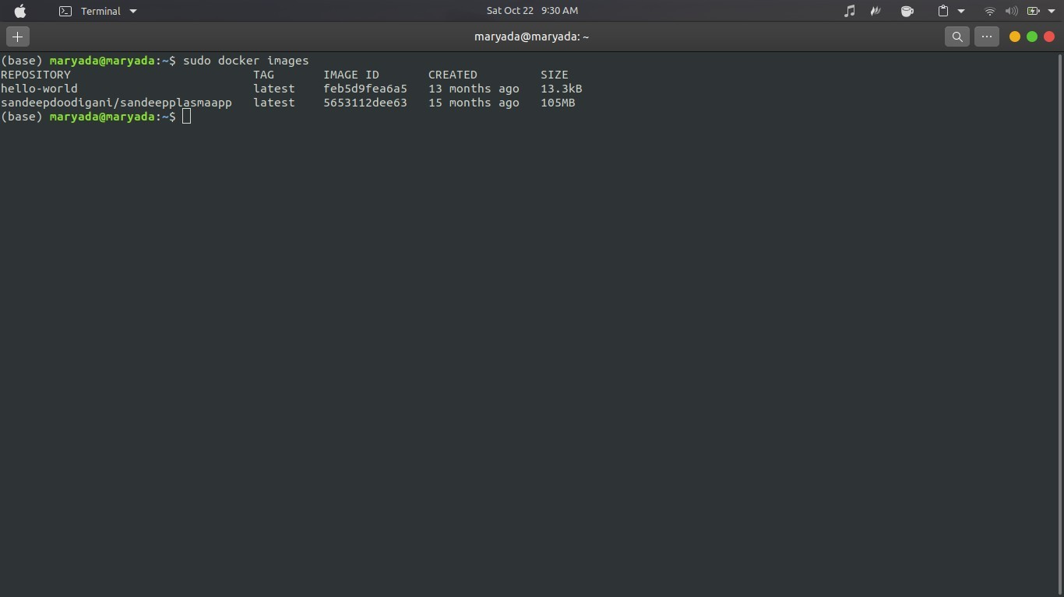

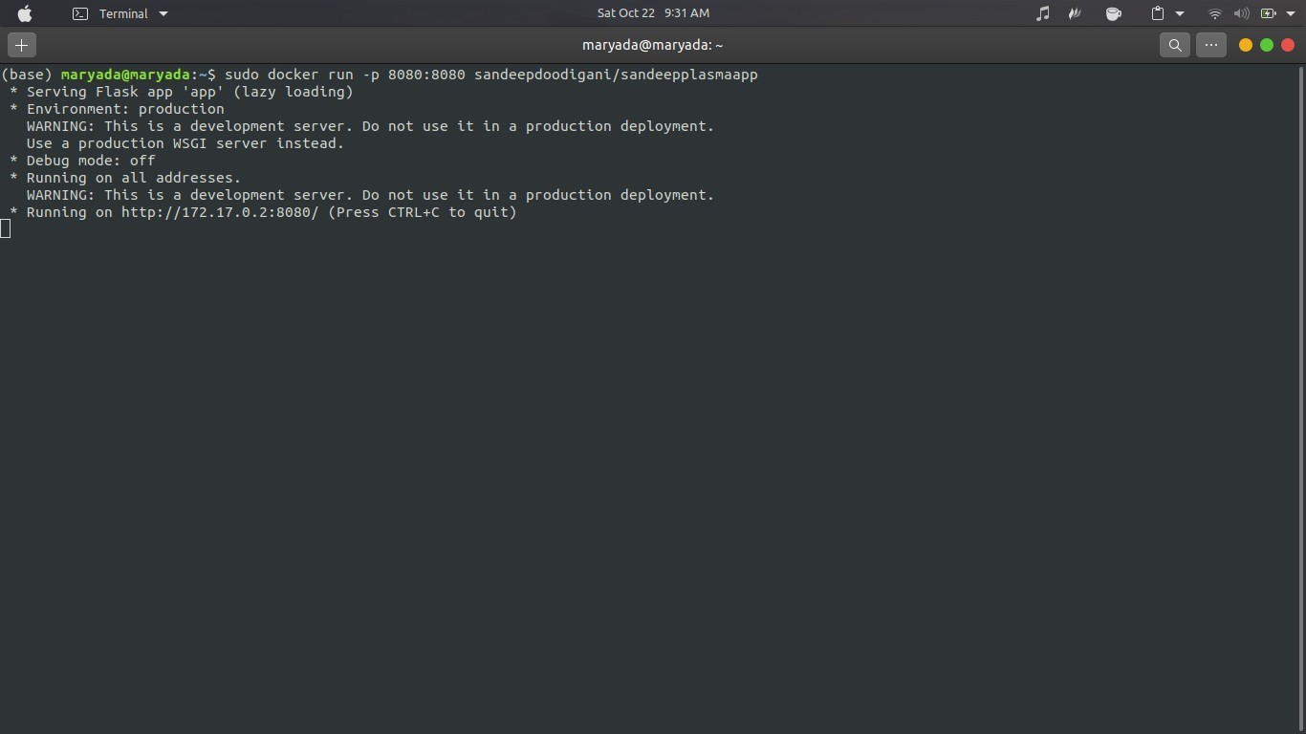

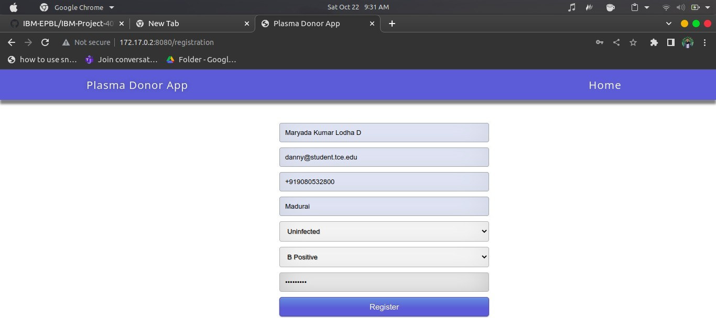

1. Create a docker file for the jobportal application and deploy it in Docker desktop application.

Dockerfile:

FROM python:3.6 WORKDIR /app ADD . /app

COPY requirements.txt /app

RUN python3 -m pip install -r requirements.txt RUN python3 -m pip install ibm_db

EXPOSE 5000

CMD ["python","app.py"]

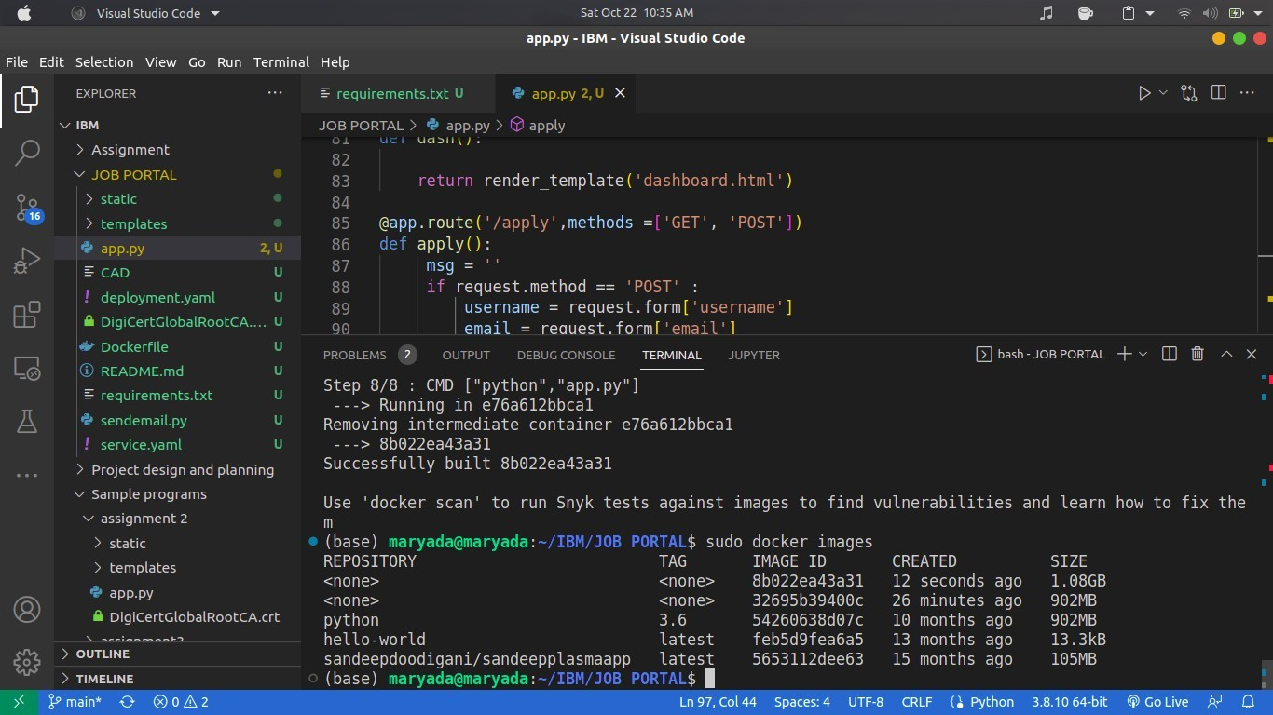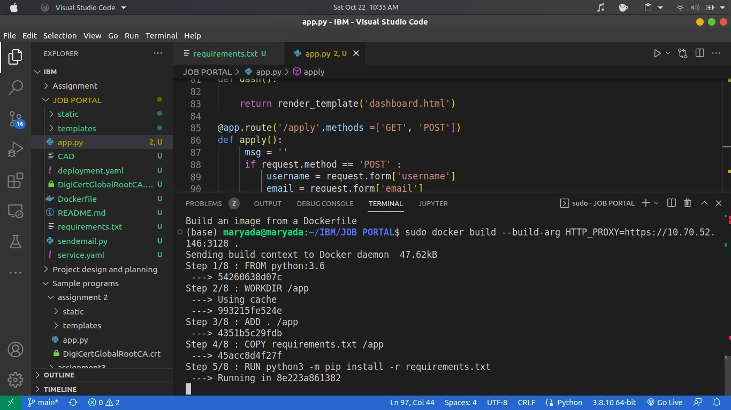

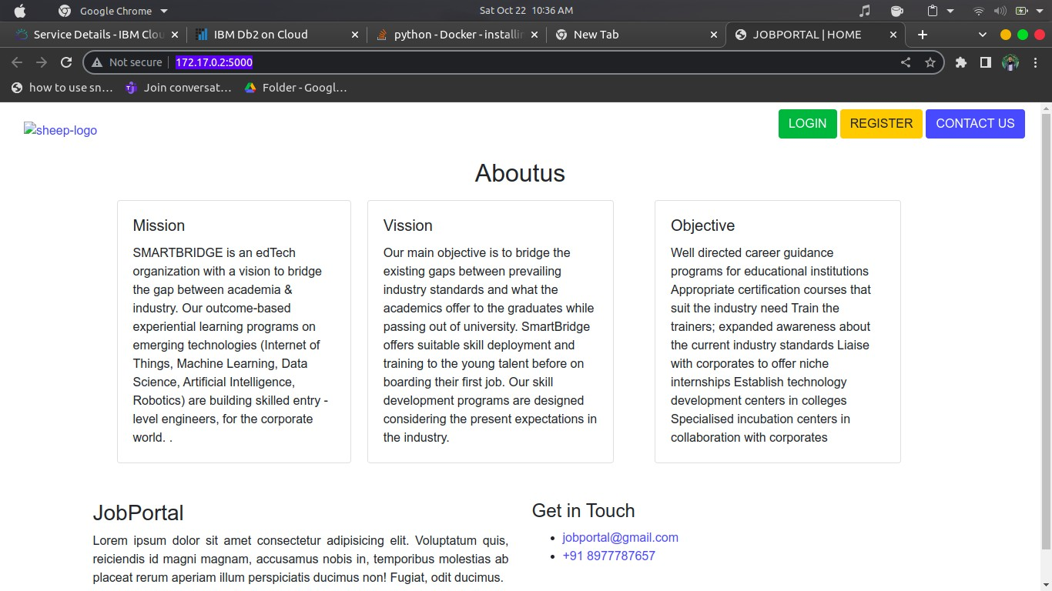

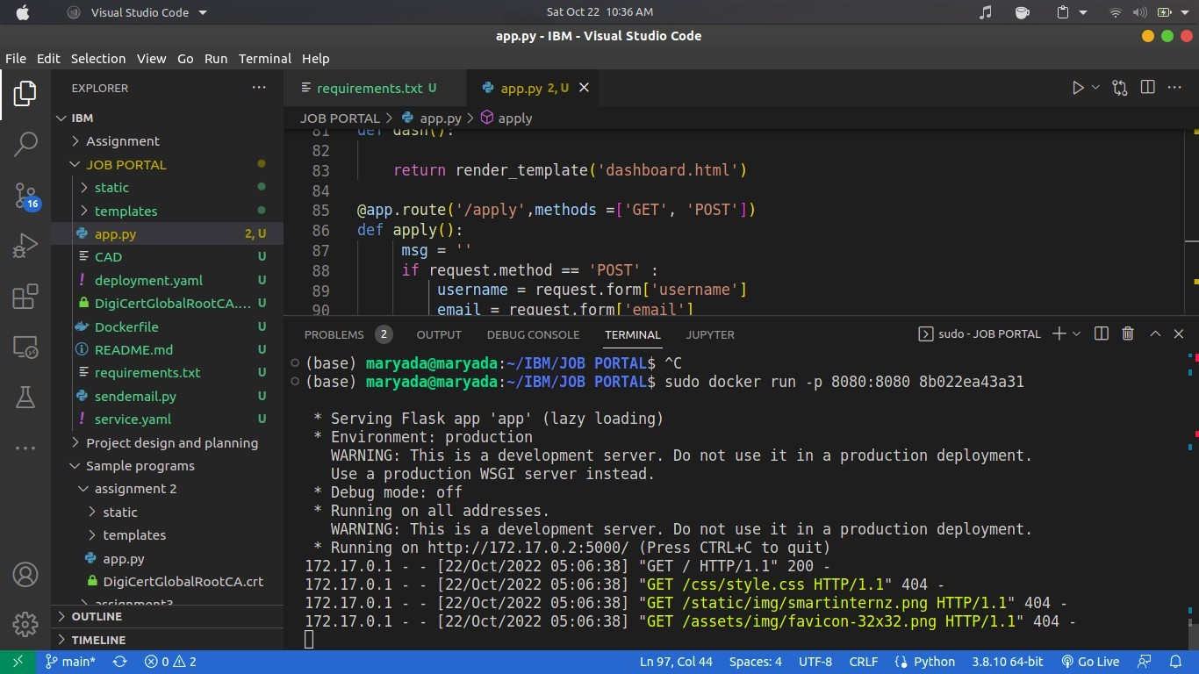

1. Create a IBM container registry and deploy helloworld app or jobportalapp.

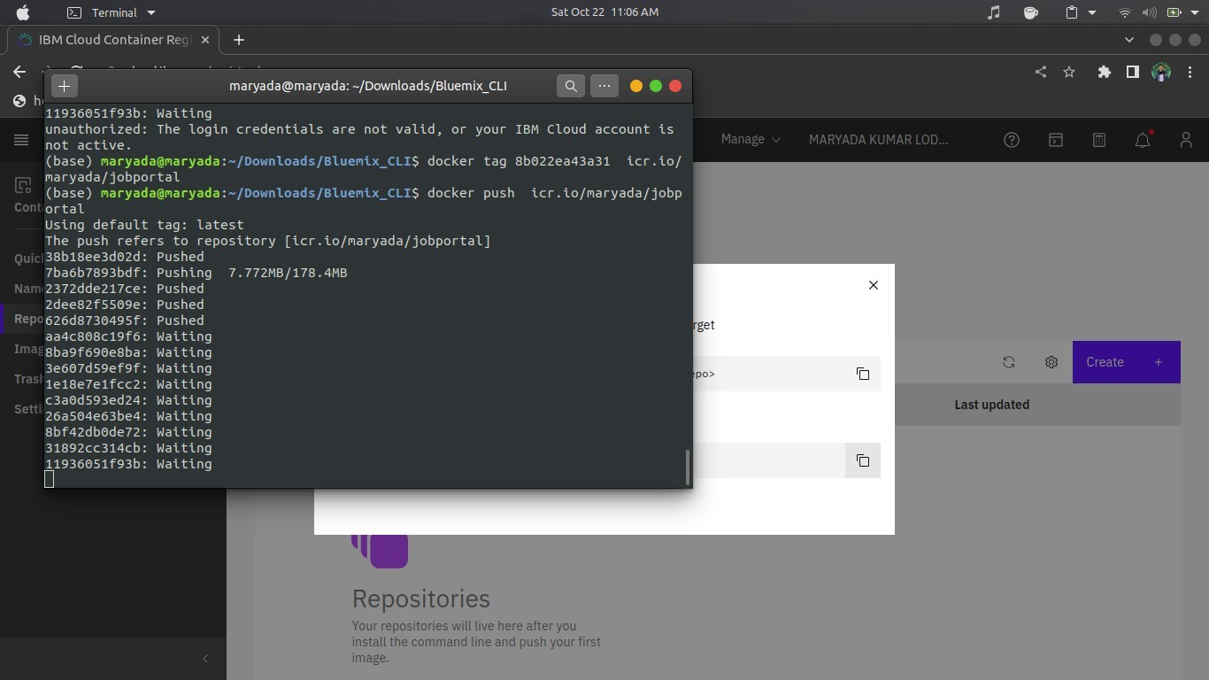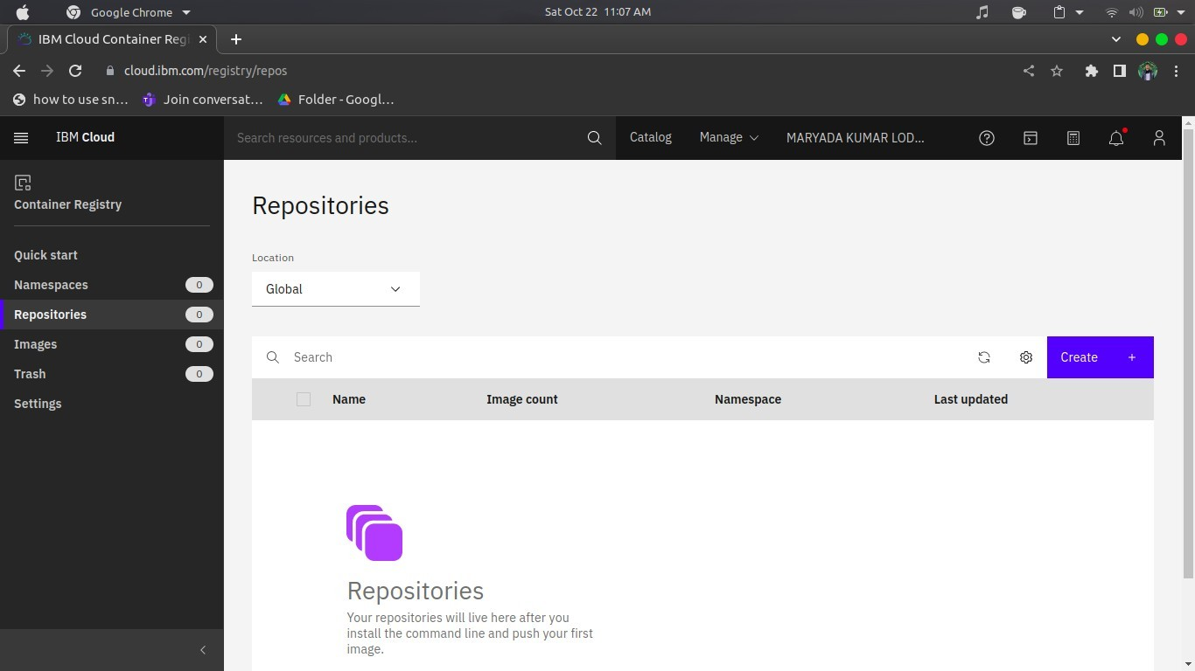

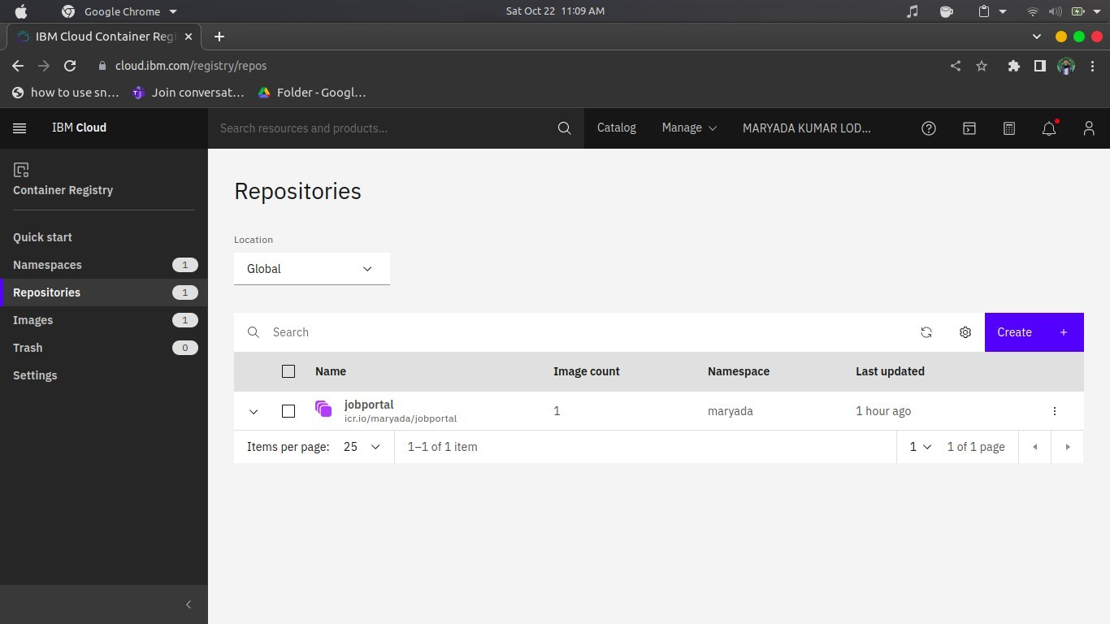

1. Create a Kubernetes cluster in IBM cloud and deploy helloworld image or jobportal image and also expose the same app to run in nodeport.

